Exercise 1

Database name: Hospital.

Entities: Room, Medicine, Patient, Employee, Role.

Attributes:

* Employee: ID, First name, Last name, email, phone number, Role.
* Patient: ID, First name, Last name, age, condition.
* Room: number, patientID.
* Role: employeeID, role.
* Medicine: name, patientID.

Relationship:

* Many to Many:
  + Employee - patient.
  + Patient – medicine.
* One to Many:
  + Role – Employee.
* One to One:
  + Patient – room.

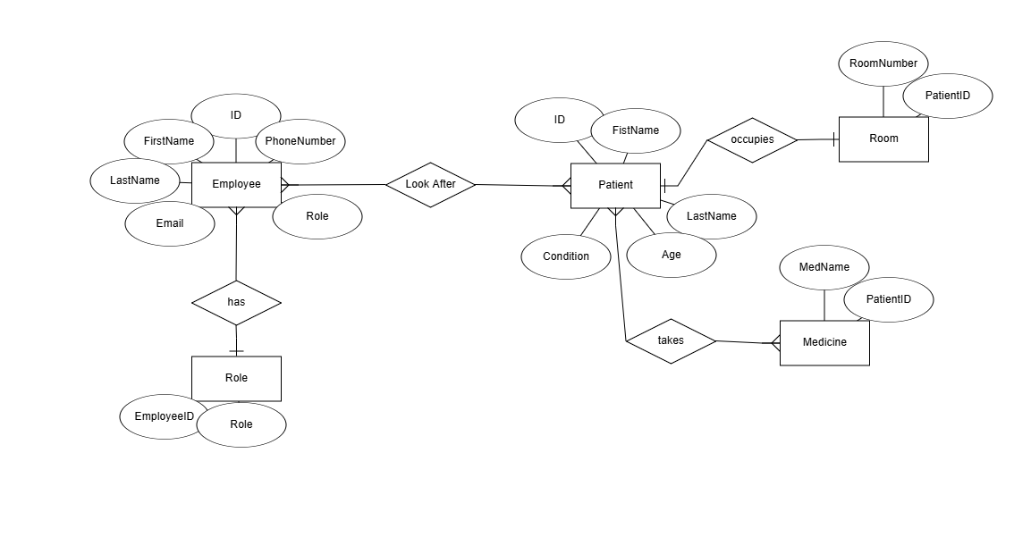ER Diagram:

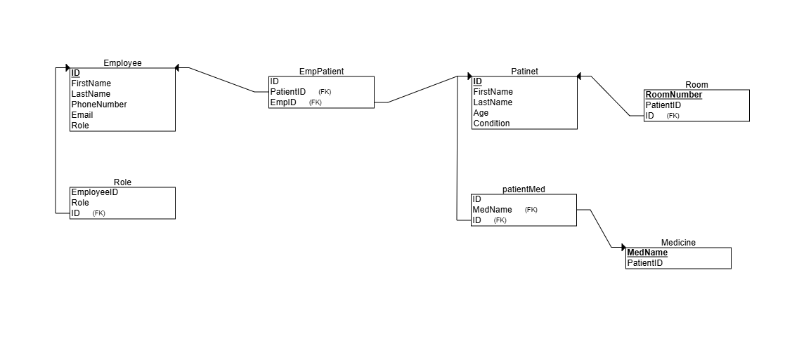Schema Diagram: